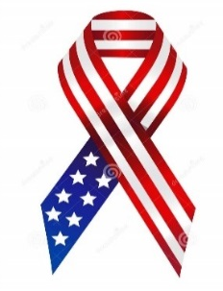
Honor our Troops Golf Classic
Friday, September 22 , 2023
Olive Branch Country Club
Benefitting:
The Military Order of the Purple Heart
And these local Veterans organizations:
VA Veterans Services, VFW, Marine Corps League, Patriot Guard Riders and American Legion
www.honorourtroopsclassic.com

Player #1____________________________________Cell# __________________
Player #2 ___________________________________ Cell# ___________________
Player #3 ___________________________________ Cell#____________________
Player #4 ___________________________________ Cell# ____________________
$ 500.00 per Team (Tax Deductible) ** limited to first 36 teams**
Entry includes ALL FESTIVITES-Honor Our Troops Classic Tax#: 88-2891470

Method of payment: Check # __________ Cash ________ Credit Card__________
Name on Card:_____________________________________________________
Card # _______________________________Expires: ___________ CVV# _______
ZIP CODE associated with card: __________________
1:00 pm Shot Gun Start – 12:30 p.m. Flag Raising -In Check starts at 11:00 a.m.
You may email this completed form to: honortroopsclassic@gmail.com
Or call:
OBCC ProShop: 662-895-1555 or Jim Gore 901-493-4179 or
Bob Buntyn 662-812-1008

